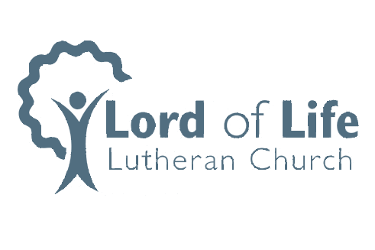

Dear Lord of Life Members:

Many of you will remember that investigations into the building of a columbarium on the grounds of Lord of Life were begun some time ago. The committee has received the necessary approvals from the City of Asbury and we are pleased to announce the commencement of this project.

A columbarium is a repository for cremated remains, organized into individual niches, with exterior identification of the person(s) inurned. The columbarium will be located on the church property near the large cross. The structure will be made of mahogany colored granite with black face plates containing 32 niches. Each niche can hold up to two standard cremation urns or one companion urn.

The tradition of burial near their church is meaningful and important to many. A columbarium provides an opportunity to continue this tradition on Lord of Life’s property. Additional information can be found on the Lord of Life website and an informational meeting will be held at 9:15 on Sunday, May 19.

In Christ,.

The Columbarium Committee

Phil Granovsky, Coordinator (563) 582-1437 pagranovsky@gmail.com

Van Waggoner, Assistant Coordinator (563) 580-2699 vanwaggoner@gmail.com