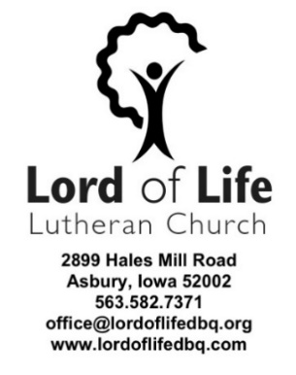

BAPTISMAL CANDIDATE
Preferred Date of Baptism: ______________________ Service Time: ___ 8:00am ___ 10:30am
Second Option Date of Baptism: _________________ Service Time: ___ 8:00am ___ 10:30am
(Summer Service Times – June, July & August - are Saturdays @ 4:00 pm/ Sundays @ 9:00 am)
Baptismal Candidate’s Name: _____________________________________________________
Address: __________________________________ City: _____________ State/Zip___________
DOB: ______________ M or F Home Phone: ___________________ Cell: __________________
eMail: ____________________________@__________________ .com | .org | .net
Place of Birth: City____________________ State____________
Parent’s Names (if candidate is a child): ____________________________________________
____________________________________________
Members or Associate Members at Lord of Life? __ YES __ NO __ Interested
Sponsors: _____________________________ Address: ______________________________
______________________________
______________________________
Sponsors: ______________________________ Address: ______________________________
______________________________
______________________________

